NAME :HASSAN YASEEN
ROLL NO: 23-SE-14

clc;
clear;
close all;

% Read image
img = imread('cameraman.tif');
img = im2double(img);

% Add noise
noisy = imnoise(img, 'salt & pepper', 0.05);

% Get size
[m, n] = size(noisy);

% Zero padding
padded = zeros(m+2, n+2);
padded(2:m+1, 2:n+1) = noisy;

% Output image
output = zeros(m, n);

% 3x3 averaging kernel
kernel = ones(3,3) / 9;

% Apply filter manually
for i = 1:m
for j = 1:n
sum = 0;
for x = 1:3
for y = 1:3
sum = sum + padded(i+x-1, j+y-1) * kernel(x,y);
end
end
output(i,j) = sum;
end
end

% Display
subplot(1,3,1); imshow(img); title('Original');
subplot(1,3,2); imshow(noisy); title('Noisy');
subplot(1,3,3); imshow(output); title('Mean Filter Output');

OUTPUT:
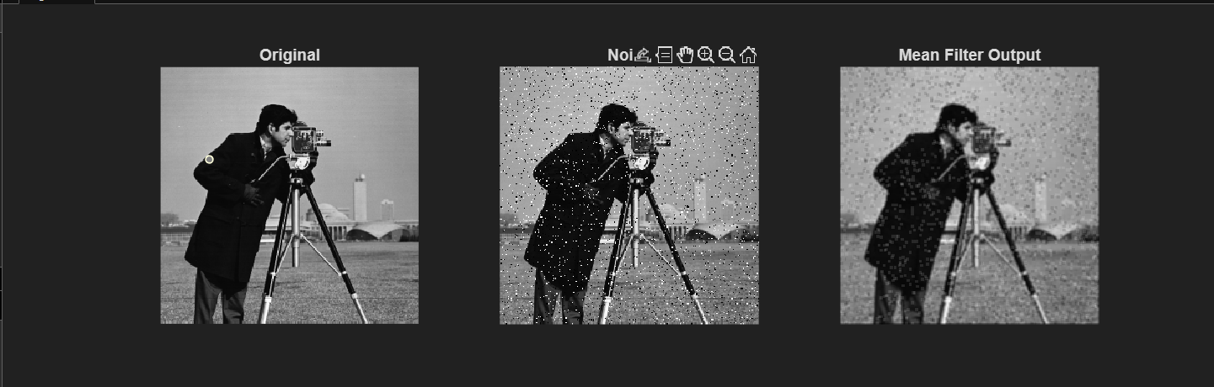

TASK 2:
>> % Median Filter
median_output = zeros(m,n);

for i = 1:m
for j = 1:n

window = zeros(1,9);
k = 1;

for x = 1:3
for y = 1:3
window(k) = padded(i+x-1, j+y-1);
k = k + 1;
end
end

sorted = sort(window);
median_output(i,j) = sorted(5); % middle value

end
end

% Display comparison
figure;
subplot(1,3,1); imshow(noisy); title('Noisy Image');
subplot(1,3,2); imshow(output); title('Mean Filter');
subplot(1,3,3); imshow(median_output); title('Median Filter');
>>

OUTPUT:
